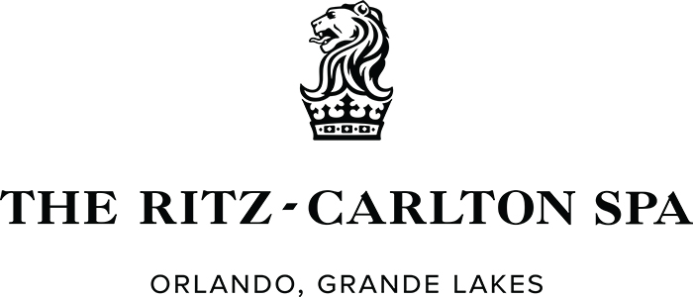

Treatment Request Form

We invite you to relax and unwind at The Ritz-Carlton Spa® during the 2017 CII Annual Conference and take advantage of the 15% savings that you will receive with any spa service of your choice.

Please complete this form with your preferred service and appointment time
and email it to Maryam Montoya, Spa Sales Coordinator at maryam.montoya@ritzcarlton.com

Guest Name |  | I am:  Male Female
Guest Phone
Conference Name
Email Address
(needed for confirmation)

Click the link below to be directed to The Ritz-Carlton Spa Menu:
The Ritz-Carlton Spa at Grande Lakes Orlando Florida Resort and Luxury Hotel.

Please indicate your appointment preference below. We will make every effort (based upon availability) to accommodate your request as close as possible to the requested time. Due to logistics of group bookings, we are unfortunately not able to guarantee preference of male or female therapist.

Preference | Requested Service & Enhancement | Male or Female Service Provider | Requested Time
1st Choice
2nd Choice

Please plan to arrive 30 minutes prior to your appointment to allow for a leisurely check-in and to make full use of our outdoor pool, sauna, steam room and whirlpools.

Maryam Montoya │Spa Sales Office │The Ritz-Carlton Spa®, Orlando, Grande Lakes
4024 Central Florida Parkway │ Orlando, FL, 32837 │ 407.393.4209

